IELTS Academic Writing Task 2 – Sample Task
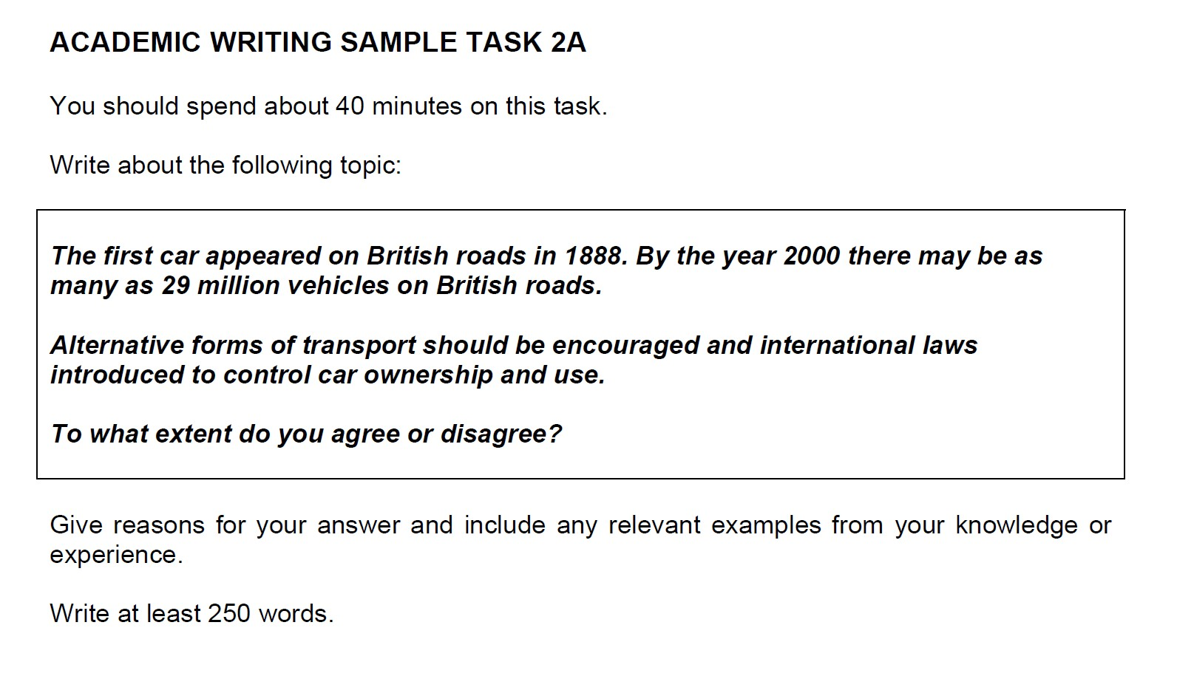

Academic Writing, organising paragraphs (IELTS Task 2): Worksheet 1

Table 1

Encouraging people to use bicycles or public transport would have many benefits for us as individuals and as a society.
Firstly it would help us to be healthier and happier.
Cycling to work or walking between your home or place of work and the nearest bus stop or train station will help you maintain or even improve your fitness.
They are also less stressful ways of commuting than sitting in a traffic jam and cycling can even help you reduce your stress.
Secondly, these ways of travelling are better for our cities and more environmentally friendly.
If more people cycled or took public transport to work there would be a dramatic reduction in traffic congestion making our cities less stressful places to be.
Less traffic also means less pollution and cleaner air.
Encouraging greater use of cycles and public transport could therefore improve our standard of living through better health and a more pleasant, greener environment.

Table 2

Topic sentence | First reason |  | Second reason
Concluding statement |  | Evidence to support the first reason
Evidence to support the second reason

Academic Writing, organising paragraphs (IELTS Task 2): Worksheet 2

Example paragraph structure:

Topic sentence | Encouraging people to use bicycles or public transport would have many benefits for us as individuals and as a society.  Firstly it would help us to be healthier and happier. Cycling to work or walking between your home or place of work and the nearest bus stop or train station will help you maintain or even improve your fitness. They are also less stressful ways of commuting than sitting in a traffic jam and cycling can even help you reduce your stress. Secondly, these ways of travelling are better for our cities and more environmentally friendly. If more people cycled or took public transport to work there would be a dramatic reduction in traffic congestion making our cities less stressful places to be. Less traffic also means less pollution and cleaner air. Encouraging greater use of cycles and public transport could therefore improve our standard of living through  better health and a more pleasant, greener environment.
First reason
Evidence to support the first reason
Second reason
Evidence to support the second reason
Concluding statement

……………………………………….. fold here ……………………………………………………………

Reason | Evidence/supporting arguments
Healthier | cycling, walking to bus stop = fitter less stressful
better for cities + environment | less traffic = nicer cities  = less pollution

Academic Writing, organising paragraphs (IELTS Task 2): Worksheet 3

Reason | Evidence/supporting arguments

Reason | Evidence/supporting arguments

